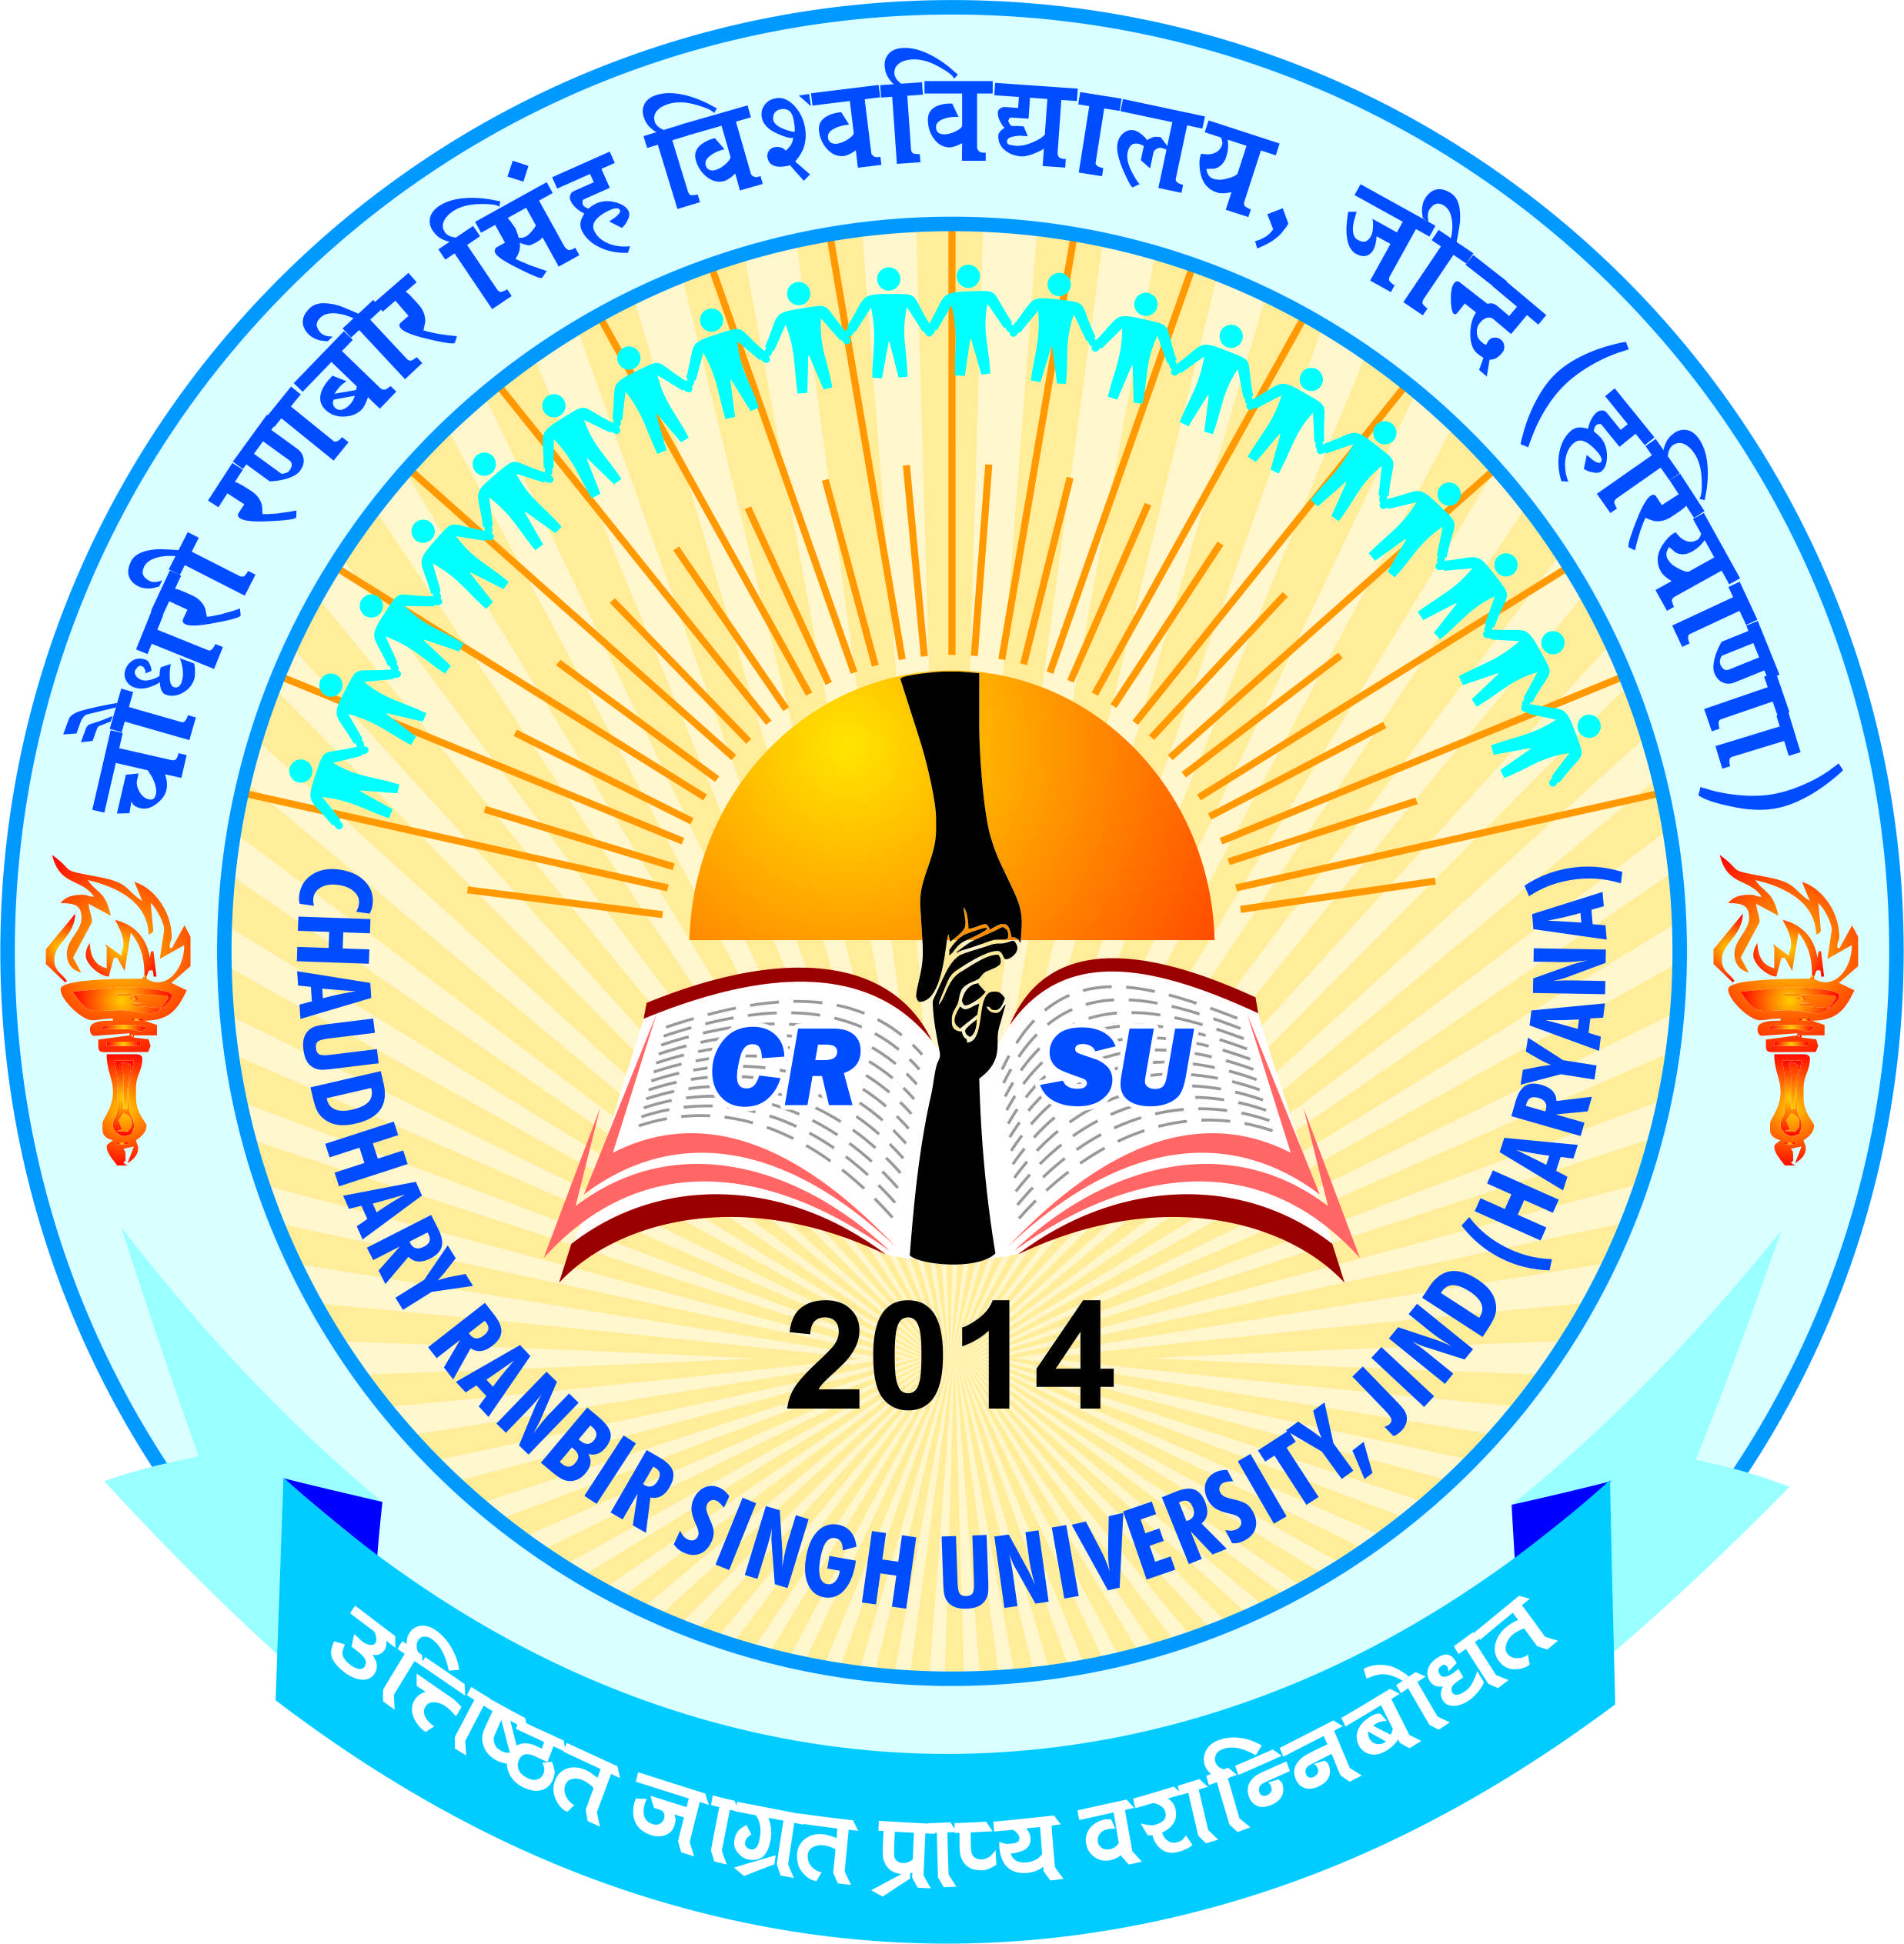 | pkS/kjh j.kchj flag fo'ofo|ky;]thUn  Chaudhary Ranbir Singh University, Jind  (Established by the State Legislature Act 28 of 2014)

APPLICATION FORM FOR TEACHING POSTS (DEPUTATION)-Advt. No.04/2017

Application No. .............................  (To be filled in by the office) | A passport size  recent photograph of  the candidate duly attested by a gazetted officer must be pasted here

NOTE :
i. Application form should be properly filled in.
ii. Self attested copies of all Certificates/Testimonials should be attached.
Originals will have to be shown at the time of interview.
iii. Persons in employment should send their applications through their employer.
They may, however, send a copy in advance, on the prescribed application form.
iv. Incomplete form and those received after the expiry of prescribed date will not be entertained and will
stand rejected summarily :
v. Only eligible candidates should apply for the post.
vi. Prescribed qualifications may be seen on the University Website www.crsu.ac.in

- Post applied for _______________________________________

Department __________________________________________

- Name of the Candidate (in Capital Letters) ____________________________________

- Father’s Name __________________________________________________________

- Gender ( M/F) ___________Married/Unmarried___________ Nationality ___________

5. Whether differently abled Yes / No

- Whether belong to SC/BC/SBC/ESM ______________________________________

- Date of birth and place ___________________________________________________

- Date of Joining (In case of CAS)___________________________________________

- Present Designation _____________________________________________________

- Date of Placement in the Reader/Selection Grade______________________________

- Date of Placement of Assistant Professor Stage II/Stage III_______________________

- Date of Placement as Associate Professor/ Professor___________________________

- API Score Earned under various categories: Category I:

Average of the sessions under consideration= Category II:

Average of the sessions under consideration=Category III:
- Educational Qualifications: (Strike off which is not applicable):
Exam Passed | Univ./Board | Year of Passing | Max. Marks | Marks obtained | % of Marks | Result
10th
12th
BA/B.Sc./B.Com/
B.Tech. etc.
M.A./M.Sc./M.Com/ M. Tech. etc.
NET/SLET
M.Phil
Ph.D.
Any other

- Total teaching experience (full time) in College/University:

Under-Graduate ..……………… Post-Graduate ……………………………………
16. Total Research Experience ……………………………………………………………
17. Field(s) of Specialization ……………………………………………………………….
18. Employment Details (in Chronological Order):
Sr. | Name of Institution | Designation | From | To | Pay Scale/
No. |  |  |  |  | Consolidated salary
(i)
(ii)
(iii)
(iv)

- Guidance/Supervision of Ph.D. Theses:

  - Number of Candidates registered at present …………………………

  - Number of Candidates who have completed Ph.D. …………………

20. Language (s) known Read Write Speak

- ……………… ……………… ………………

- ……………… ……………… ……………

21. Present Basic Pay ………………………… AGP………………... in the Pay..................

Band of Rs. ………………………………………Total Emoluments ………………………

- Publications:

Publications |  |  | Total | During the period under | Major Publications
 |  |  | (Attach the list | consideration for | as per requirement
 |  |  | with details) | promotion (Attach ten | (Attach ten copies of
 |  |  |  | copies of the list with | the publications)
 |  |  |  | details)
Books
Papers in Journals
Chapters in Books
Papers | in | the
Proceedings of |  | the
Conferences
Patents
Additional
Information, if any

23 List of Enclosures (Give supportive documents of the claims made in the application):

1. | …………………………………… | 2. | ……………………………….
3. | ……………………………………. | 4. | …………………………………
5. | …………………………………… | 6. | …………………………………

I certify that the foregoing information given by me is correct, complete to the best of my knowledge and belief and no material information has been concealed. I am not aware of any circumstances which may impair my fitness or employment.

Date: ……………………… Signature of the candidate

Permanent Address: Correspondence Address

(in Capital Letters) (in Capital Letters)

………………………………………….. …………………………………………………
………………………………………….. …………………………………………………
………………………………………….. ………………………………………………...
………………….Pin …………………. ……… ………………Pin ……………………………

Email:

Mobile No.:

Forwarded by

Head/Dean
CERTIFICATE FROM THE EMPLOYER, IF ANY

The application of Miss/Mrs./Shri/Dr. .............................................................. who is at present working
as ........................................................ in the ..................................................................... (Deptt./
Organisation) is recommended and forwarded for consideration for the post of .................................. to the Registrar Chaudhary Ranbir Singh University,Jind-126102. In case, he/she is selected on deputation in the University,he/she will be relieved of his/her present position.
Further, it is certified that-
- no vigilance case is either pending or being contemplated against the Faculty(s)
- no major/minor penalty has been imposed on the Faculty(s) during the last 10 years
- the integrity of the Faculty is beyond doubt

Place ........................... Signature of the Head

(Seal of Office)

Appendix-I

ACADEMIC PERFORMANCE INDICATORS

(Please see detailed instructions of the PBAS proforma before filling out this section) Period:______________________________

Category I: Teaching, Learning and Evaluation Related Activities

Maximum Scores Allocated: 125

Minimum API Score Required: 75

1. Lectures, Seminars, Tutorials, Practicals, Contact Hours (give semester-wise details, where necessary)

Sr. | Course/Paper | Mode of | Hours per | % of classes | Average of | API Score
No. |  | Teaching* | week | taken as per | the
 |  |  | allotted | documented | percentages
 |  |  |  | record

 |  | *Lecturer (L), Seminars (S), Tutorials (T), Practical (P), Contact Hours (C)
 | 2. Lectures or other teaching duties in excess of the UGC norms
Sr. |  | Course/Paper | Mode of |  | Hours per week |  | API Score
No. |  |  | Teaching
 |  |  |  | Total

- Preparation and Imparting of knowledge / instructions as per curriculum; syllabus enrichment by providing additional resources to students
Sr. | Course/Paper |  | Reading/Instructional | API | Additional | API
No. |  |  | material consulted & | Score | Resource | Score | Total
 |  |  | prescribed | (Max. 15) | provided | of | API Score
 |  |  | (a) | of (a) | (b) | (b)
 |  |  |  |  |  |  | Average (a) +
 |  |  |  |  |  |  | Total (b)
 |  | Average API (a) |  |  | Total API (b)

- Use of participatory and innovating teaching-learning methodologies, updating of subject content, course improvement etc.

Sr. No. | Short Description | API Score

Total Score

(Max. Score: 20)

5. Examination duties as per allotment

Sr. No. Type of Examination Duties | Duties Assigned | Duties Performed | API Score

Total Score

Total API Score Earned:

Category II: Co-Curricular, Extension and Professional Development Related Activities

Maximum Scores Allocated: 50
Minimum API Score Required: 15

Sr. | Nature of Activity | Score Earned
No.
1. | Extension, Co-curricular and Related Activities
 | Total Score (Max. Limit: 20 points)
2. | Contribution to Corporate life and management of the department and
 | institution through participation in academic and administrative committees
 | Total Score (Max. Limit: 15 points)
3. | Professional Development Related Activities
 | Total Score (Max. Limit: 15 points)

Total API Score Earned:

Category III: Research and Academic Standards

III A: |  | Research Papers Published in Journals or Conference Proceedings
Sr. |  | Title with |  | Journal, | Whether |  | Impact |  | ISSN / |  |  | Whether you are |  |  | API Score
No. |  | name of |  | Volume, | indexed/ |  | factor, if |  | ISBN |  | first/Principal/corresponding
 |  | author(s) as |  | Year, | refereed/ |  | any |  | No., if |  | author or supervisor/mentor
 |  | appearing in |  | Page | Non- |  |  |  |  | any |  | or other author
 |  | the |  | Numbers | refereed or
 |  | publication |  |  | Conference
 |  |  |  |  | Proceedings
1
2
3
4
5
6
7
III B (i): Books published
Sr. |  | Whether Text of Reference Book, |  |  |  |  | Title with |  |  | Book Title, |  | ISSN/ | Total |  | API Scores
No. |  | published by International publishers/ |  |  |  |  | name of |  |  | Editor, |  | ISBN | No. of |  | (To be shared
 |  | Subject books by National level |  |  |  |  | authors as |  |  | Publisher |  | No, if | authors |  | equally by all
 |  | publishers or State and Central Govt. |  |  |  |  | appearing in |  |  | Year, Page |  | any |  |  | methods)
 |  |  |  |  |  |  | the |  |  | Numbers
 |  | Publications with ISSN/ ISBN /Subject
 |  |  |  |  |  |  | publication
 |  | Books by other local publishers with
 |  |  | ISSN/ISBN
1
2
3
4

III B (ii): Research Publications (Chapter in Books/Monograph other than refereed journal articles)

Sr. | Chapter in | Title with | Book Title, | Whether contributed to edited | ISSN/ | Total | API Scores
No. | a Book/ | name of | Editor, | knowledge based volume | ISBN | No. of | (To be shared
 | Monograph | authors as | Publisher | published by International | No, if | authors | equally by all
 |  | appearing in | Year, Page | Publishers or in knowledge | any |  | methods)
 |  | the | Numbers | based volume of Indian/National
 |  | publication |  | Level Publishers with
 |  |  |  | ISSN/ISBBN Numbers and with
 |  |  |  | numbers of National and
 |  |  |  | International Directories
1
2
3
4

III C (i) & (ii): Research Projects
Sr. | Title & Type of | Carried out | Funding | Period | Grant/Amount | API Score
No. | Projects(Sponsored/Consultancy) | / On Going | Agency |  | Mobilized
 | (Major/Minor) |  |  |  | (Rs in lakhs)
1
2
3
4

III C (iii): Completed Projects Quality Evaluation
Sr. |  | Title & Type of |  |  |  | Funding |  |  | Period |  |  | Grant/Amount |  |  |  | Whether |  |  |  | API Score
No. |  |  | Project |  |  | Agency |  |  |  |  |  | Mobilized |  |  |  | accepted
 |  | (Major/Minor) |  |  |  |  |  |  |  |  |  | (Rs. Lakhs) |  |  |  |  | from
 |  |  |  |  |  |  |  |  |  |  |  |  |  |  |  | Funding
 |  |  |  |  |  |  |  |  |  |  |  |  |  |  |  |  | Agency
1
2
III C (iv): Projects Outcome/Outputs
Sr. |  | Title & Type of |  |  |  | Funding |  | Period |  |  | Grant/Amount |  |  | Whether Patent/ |  |  |  |  |  |  | API Score
No. |  |  | Project |  |  | Agency |  |  |  |  | Mobilized |  |  |  | Technology
 |  | (Major/Minor) |  |  |  |  |  |  |  |  | (Rs. Lakhs) |  |  | Transfer/Product/
 |  |  |  |  |  |  |  |  |  |  |  |  | Process/Major Policy of
 |  |  |  |  |  |  |  |  |  |  |  |  | Govt. (Bodies at Central
 |  |  |  |  |  |  |  |  |  |  |  |  |  | and State Level)
1
2
III D: Research Guidance
Class |  |  |  |  |  | No. of Students |  |  |  |  | Thesis/Dissertation |  |  |  |  |  | Degree Awarded |  |  |  | API Score
 |  |  |  |  |  |  |  |  |  |  | Submitted
PG Courses
(Dissertation |  |  | less than | 1
semester)
PG | Courses |  | (Dissertation
more than 1 semester)
M. Phil.
Ph. D.

III E (i): Refresher Course, Methodology workshops, Training, Teaching-Learning Evaluation Technology

 | Programmes, Soft Skills development Programmes, Faculty Development Programmes
Sr. No. | Programme | Duration | Organized by | API Score

Total Score (Max. Limit: 30 points)

III E (ii): Participation and Papers presented in Conferences/Seminars/Workshops/Symposia etc.

Sr. | Title of the | Presented | Title of the | Date (s) | Whether International/ | Whether | API Score
No. | paper | by | Conference/ | of the | National/ State/ | published
 | presented |  | Seminar etc | event | Regional/ University | in the
 |  |  | & Organizer |  | or College level | proceeding
 |  |  |  |  |  | s

III E (iii): Invited for conferences/ seminars/ workshops/ symposia to deliver lectures/ Chair sessions

Sr. | Whether |  | Title of the | Title of | Date(s |  | Organizer | Whether | API Score
No. | Lecture |  | Lecture | Conference/ | ) of |  |  | International/
 | delivered / |  | delivered | Seminar etc. | the |  |  | National/ State/
 | Academic |  |  |  | event |  |  | Regional/
 | Session |  |  |  |  |  |  | University or
 | Chaired |  |  |  |  |  |  | College level
1
2
3
4
 |  |  |  | OTHER RELEVENT INFORMATION
Please give details of any other credential/ significant achievement not mentioned earlier:
Sr. No. |  |  |  | Details (Mention Year, Venue etc. where relevant)

Total API Score Earned:

pkS/kjh j.kchj flag fo'ofo|ky;]thUn
Chaudhary Ranbir Singh University, Jind
(Established by the State Legislature Act 28 of 2014)

IMPORTANT INSTRUCTIONS FOR ADVERTISEMENT

Candidates must go through the following instructions before filling up the application form:

- Name of the post applied for must be super-scribed at the top of the envelope as under:-
Application for the post of ___________________________.
- The eligible faculty for the above positions working in the Central/ State Universities and willing to work at Chaudhary Ranbir Singh University, Jind on deputation basis may apply through proper channel. The complete application forms should reach the office of the Registrar, Ch. Ranbir Singh University, Jind by 31st October, 2017. However an advance copy of the same can be sent by registered post or at email ID to registrar@crsu.ac.in by 23rd October, 2017.
- The incomplete applications and received after due date shall be rejected. The applicants must enclose the self attested copies of the documents.
- Application form is available on university website.

