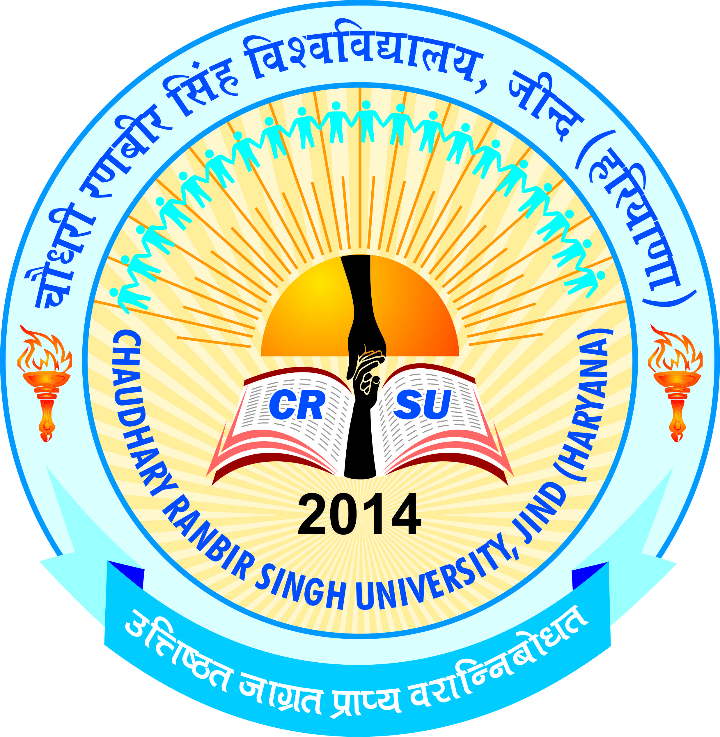 | pkS/kjh j.kchj flag fo'ofo|ky;]thUn  Chaudhary Ranbir Singh University, Jind  (Established by the State Legislature Act 28 of 2014) | 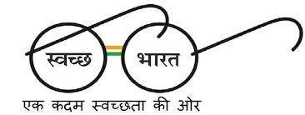
Public Notice (advt. no. 6/2016)

Schedule for COMPUTER TEST(s) & Interview- ASSISTANT REGISTRAR
It is for general information to the candidates who have qualified the written examination for the post of Assistant Registrar held on 29.01.2017 (Sunday) in response to Advt. No. 06/2016, they have to appear as per mentioned below schedule for Computer Test (s) at Chaudhary Ranbir Singh University, Jind:

Sr. No. | Name of the Post | Type of Test, Date & Time of Exam(s) | Date of Interview
1. | Assistant Registrar | Computer Test  (Objective & Practical)  22.05.2017(Monday) at 11:00 am | 24.05.2017 (Wednesday) 11:00 a.m.
It is made clear that no candidate will be allowed to appear in the computer test and interview without the attested E-admit card. The candidates who qualify the tests and shortlisted for interview will have to appear before the Selection Committee for interview as per above Schedule. The shortlisted candidates must reach the University (Conference Hall) for interview along with original testimonials before an hour i.e. 10:00 am for document verification.
Information regarding examination centre has been mentioned in the Admit Card of the applicant. The E-Admit Card along with instructions can be downloaded from the University website www.crsu.ac.in from 12.05.2017 onwards. The details of syllabus, selection criteria for the test(s) are available on University website. The candidates(s) can contact at 01681-241002, 241004 during office hours i.e. 9:00 AM to 5:00 PM. For more details visit University website www.crsu.ac.in.
Registrar

