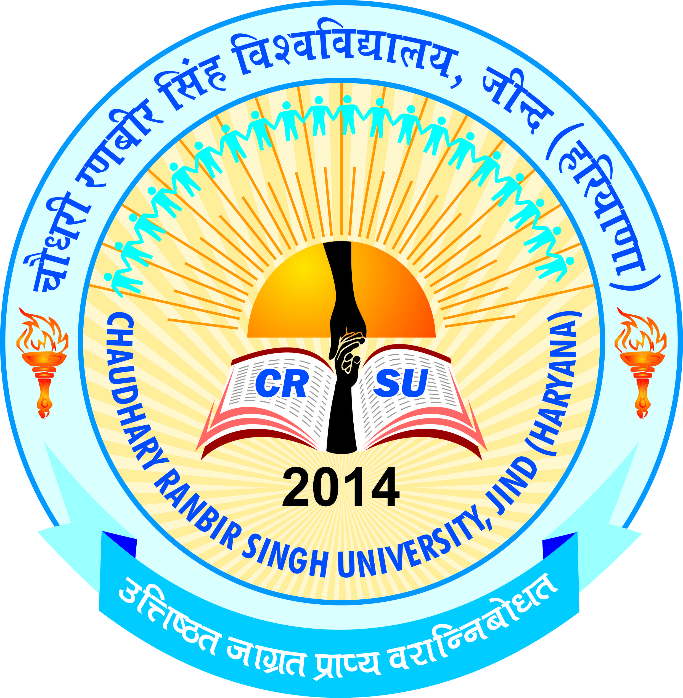 | pkS/kjh j.kchj flag fo'ofo|ky;]thUn  Chaudhary Ranbir Singh University, Jind  (Established by the State Legislature Act 28 of 2014) | 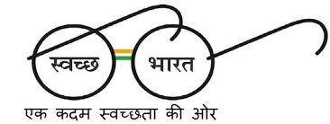
Deputy Registrar email: deputy.registrarcrsu@gmail.com

No. CRSU/DR/2016/…………… Dated:-16/05/2016
To
The Chairman / Principals
All the Education Colleges,
Haryana.

Subject: - Health Card of Girl’s Students.
Sir / Madam,
I am to inform you that, it has been generally observed that the health of girl’s students is poor in comparison to the boys. Therefore you are requested to appoint a medical check-up agency or technician to check up the HB of all the girl’s students of B.Ed., M.Ed. or other classes of your respective college. Further you are requested to upload the health data specially of Girls students of you college on the website of your college and the same may be placed at the notice board, further the same may be mailed to the Dean of Colleges i.e. deancolleges@crsu.ac.in. You are requested to update your website regularly mentioning the updation date.
The girl’s students may be motivated to participate in games, yoga, cultural activities and other activities. They may be encouraged to take balance diet so that they may not face any health problem and their HB may be increased. The health check-up of students may be checked three or four times in a section.
I hope that you will co-operate with the University and certainly do the needful at your earliest so that the health data can be checked during the inspection / visit of your college.

Dy. Registrar

